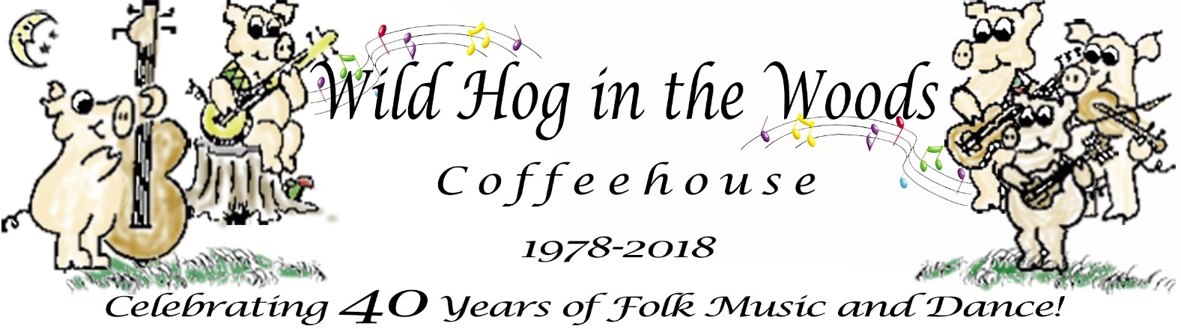
953 Jenifer Street, Madison, WI 53703 www.wildhoginthewoods.org

Wild Hog in the Woods Celebrates 40 years with award-winning Irish Folk Singer/Songwriter Aoife Scott in concert September 7th

Contact: Jamie Diana Poindexter  Phone: (608) 770-8092 (leave a message if not answered)  Email: jamiep@wildhoginthewoods.org | FOR IMMEDIATE RELEASE  August 10, 2018

Madison, Wisconsin - The Wild Hog in the Woods Coffeehouse presents in concert from Dublin, Aoife Scott, with Andy Meaney, Friday September 7, 2018, at 953 Jenifer Street (Wil-Mar Neighborhood Center), Madison, Wisconsin. Doors open at 7:00 PM, concert begins 7:30 PM.

ABOUT AOIFE SCOTT

Award-winning folk singer and songwriter based in Dublin, Ireland, Aoife Scott was born into the legendary Black family. Aoife is steadily rising to the top of the traditional and folk music scene by her own right. Fragile and ethereal one minute and strong and vibrant the next, Aoife has a dynamic and profound voice, which explores the emotional depths of her lyrics, leaving the audience entranced. Her music has a broad creative scope but is largely influenced by her own roots in folk and traditional Irish music.

Her recent accolades in 2018, have seen her named Best Folk Act at the Irish Post Music Awards (IRE), as well as Emerging Artist of the Year at the Live Ireland Awards (US). Aoife is a true veteran of the Irish and Folk Festival circuit, having performed and headlined at dozens of festivals around the globe, including Milwaukee’s Irish Fest.

Following the success of her debut album, “Carry the Day”, wherein the Irish Times praised it as “richly layered impressive debut album”, Aoife is currently writing her follow up - a second full-length album.
“Who knew 40 years ago when a small group of Madison’s folksingers created the Wild Hog that it would still be providing a wide variety of folk music and bringing talented musicians to Madison from across the Midwest, the country and from across the seas.” said Jamie Poindexter, a member of the Wild Hog in the Woods.

Find out more about Aoife Scott:
www.aoifescott.com
www.facebook.com/aoifescottmusic
www.twitter.com/aoifescott
www.irishpost.com/news/aoife-scott-wins-best-irish-folk-act-at-the-irish-post-music-awards-155761
About the Wild Hog in the Woods Coffeehouse

The Wild Hog in the Woods first opened on November 30, 1978. In the spring of 1978, several folk musicians began talking about possible outlets for folk music beyond their living rooms and record players. They wondered about finding a location which would be permanent and open to the public, a place where folks could go to hear or play folk music even if they did not know anyone in town. There weren’t many venues with small open stages where they could perform.

Posters were hung on street kiosks and store fronts around town to find other interested musicians and those who enjoyed listening to folk music. The consensus at the early meetings was that a new space was needed, and it should be themed as an informal 1960’s style coffeehouse.

Later meetings led to our incorporation as a non-profit organization based on cooperative principles. With Madison’s strong cooperative community and with a healthy concern against ‘going in over our heads’ as a commercial venture, we determined that a cooperative would be the way to go, the safest economically, and the fairest socially. All staff are members of the cooperative and volunteer their time. Musicians are not paid, they receive tips from the audience for their performance.

“We still manage the Coffeehouse by consensus, we really think cooperation is a good idea and we love to do it,” said Ben Doran, musician and volunteer.

“It’s been determined over and over again that a broad base of ideas and personal support is important for the operation and long life of the Wild Hog,” said Lisa Johnson, musician and volunteer.

Key points of interest about the Wild Hog:
- The Wild Hog in the Woods is a membership organization, a not for profit based on cooperative principles that was started by musicians in 1978 when there were not many venues at which to play their music.
- The Wild Hog operates a 60’s style coffeehouse with live folk music and other special events, workshops, dances, or in cooperation with other organizations.
- Members play an important role in the Wild Hog, volunteering their time to host the coffeehouse and other events, including promotion, booking performers, running sound, baking, newsletter and web site, and much more. We welcome new members!
- If you’re interested in performing at the coffeehouse, playing or calling at a barn dance, becoming a member, or would like to get involved with the Coffeehouse in any way, you can simply talk to the person at the admission table, contact us by email at info@wildhoginthewoods.org or visit our web site at www.wildhoginthewoods.org

PreSS KIT available
This press release and selection of photos, posters and more:
wildhoginthewoods.org/Anniversaries/2018/PressKit/index.html

More information at:
www.wildhoginthewoods.org
www.facebook.com/groups/wildhoginthewoods

-End-

